# Homework

# Create Automated Test with Sikuli

Below are some sample workflows. Create Sikuli IDE tests for them.

* Go to [www.google.com](http://www.google.com) and search for “Telerik academy” and assert that it exists in the search results.
* Go to <http://www.sikuli.org/> and record a test for finding a region object that is located inside another region (ex. find the menu bar and hover the “Videos” section inside it).
* Go to [www.google.com](http://www.google.com) and record a test for extended region. Make an initial region that contains only the letter “G” and extend it to contains “Google”.

Initial region

Extended region



* Go to <http://www.dhtmlgoodies.com/scripts/drag-drop-custom/demo-drag-drop-3.html> and record a test for dragging and dropping elements. Record the action of positioning the capitals to their corresponding countries and verify that each country contains its own capital.
* Record a test that minimized all active windows. For example the Firefox tabs.

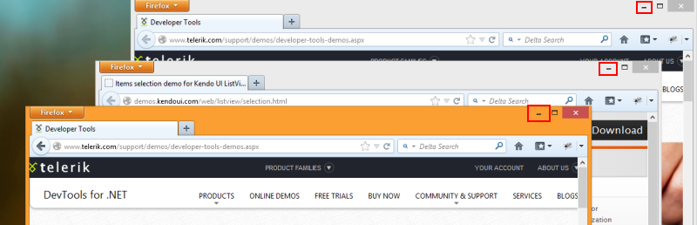

* Record a test that sends a message to a friend via Skype.
* Go to <http://www.facebook.com/> and record a test that sends a message to a friend.

Expand the test by sending multiple messages consequently.

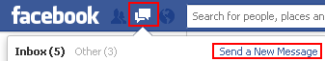

* Open **Windows Calculator** from the Star menu. Check the operations of addition, subtraction, multiplication and division. Make sure that dividing by zero is not allowed.